Figure 1 : Application Output Running Live

Figure 2: Monitoring

Figure 3: Hello World App

Figure 4: SonarQube

Figure 5: ACR

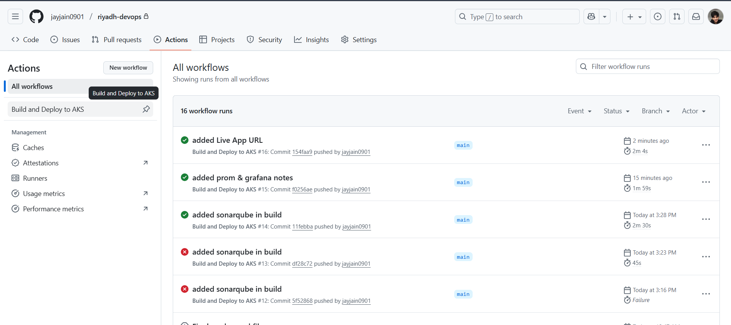

Figure 6: Github Actions Succesful run